**HOW TO MAKE A BOAT IN MINECRAFT**

In this article, you will come to know **how to create a boat in Minecraft**. Minecraft is a 3-D game sandbox video game and it is a **brick-based** game. A boat is a multi-purpose object which can be used as a vehicle and as an item. Minecraft is treated as the best game due to its features. It is an educational type of game for kids and a non-violent game can teach programming skills.

Boats are the cheapest and consistent way of traveling across vast expanses of water quickly and we can vary the speed of the boat on the situation.

**Required Items:**

* Crafting table
* 5 wooden planks

**How Boat Looks:**

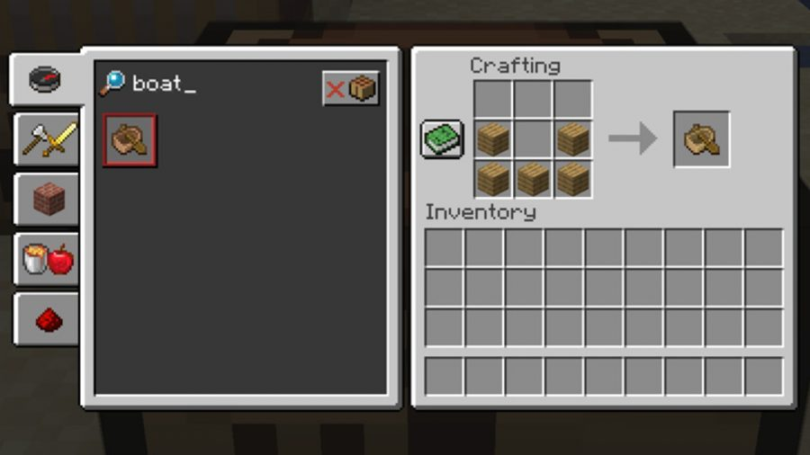

**Steps to make a boat:**

**Step1:** First we need to find oak trees and collect 5logs of an oak tree, which are used as a source to make the boat. So, our primary step in making a boat is a collection of oak trees. Which looks as shown in the below figure.

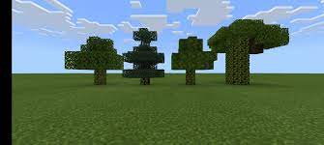

**Step2:**  After collecting oak logs, we need to place them in a crafting table which consists 3X3 grid system. We need to place them in a manner in such a way that they form the boats.

Place 2 oak logs in the second row at either of the corners and fill the last row with the oak logs.

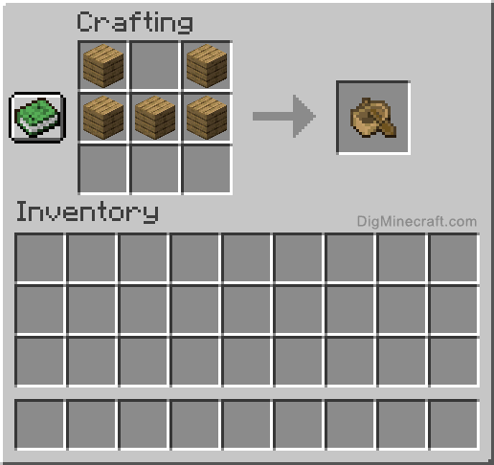

In this, way we can make a boat. Move the boat to the inventory and use them in your gameplay.

**USES OF BOAT:**

The best use of boats in Minecraft by far is the **ability to avoid fall damage.** As mentioned earlier, players do not take fall damage when falling from high places while inside a boat. Boats can be used to jump off high cliffs, or as clutch tools to avoid death when knocked off, of any high place such as an end spike.

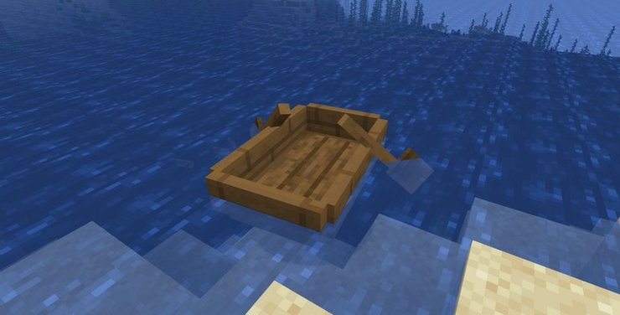

1. **MOST USES OF BOAT IN MINECRAFT:**
2. **Water Travel:** Of course, the most common way to use a boat in Minecraft is to travel fast in the water. Boats come in handy in ocean biomes where water is abundant, and land is scarce. When trekking across large areas of a map, boats are far more effective than running on foot or swimming.

Not only is traveling by boat substantially quicker than swimming, but it is also much safer. There is no risk of drowning while a player is in a boat. While players in boats are still at risk of being attacked by mobs, the wood does provide an extra barrier of protection against water mobs like drowning.

1. **Ice Travel:**  Ice is not as common as water in typical world seeds, but it can be useful nonetheless. According to the Minecraft laws of physics, boats on ice go significantly faster than on the water, making it an even more efficient method of travel.

If players wanted to connect two significant areas of a world separated by water, they could turn long strips of the water into ice, thus creating a speedy transportation system using boat travel. Additionally, using a boat on ice can help players outrun any mobs chasing after them much faster than on foot.

1. **Trapping Mobs:** Trapping mobs is one of the most unique ways to use boats in Minecraft.

Players can simply place a boat next to a mob they want to trap, then most mobs will sit down inside the boat. The mobs will be unable to leave the boat unless it is manually broken. From there, players can hop on the boat with the mob to bring it somewhere else, or they can use the trap to their advantage in battle.

Players can trap ender men in boats for a safe fight, trap villagers to move them closer to a base, trap animals to move them into a farm and so much more.

1. **Full Damage:** The best use of boats in Minecraft by far is the ability to avoid fall damage. As mentioned earlier, players do not take fall damage when falling from high places while inside a boat.

Boats can be used to jump off high cliffs, or as clutch tools to avoid death when knocked off of any high place such as an end spike. Many players use water buckets to break their fall by placing the item on the block below, just a moment before hitting the ground. Boats can be used in the same way. The only difference is that players must sit down in the boat as they land, or else they will still hit the ground too hard and die.

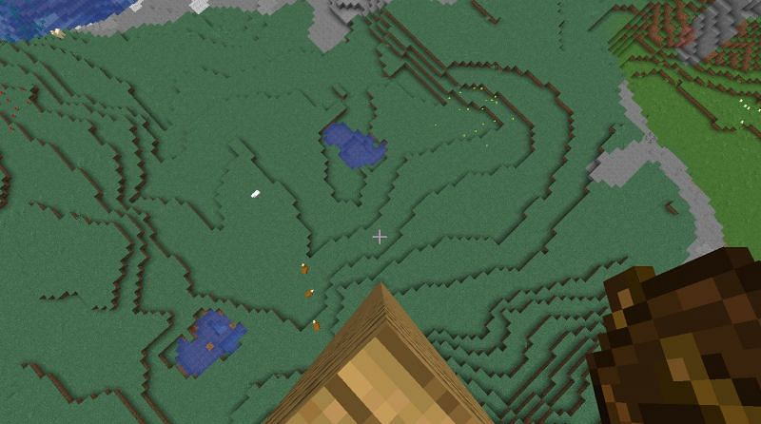

**CONCLUSION:** I hope that this article helps you a lot in creating a boat in Minecraft. This article also provides detailed information about making boat and their uses. Be sure that you placed the wooden logs correctly on the crafting table. Share the article with your friends and learn how to make a boat and have fun.

**Article by,**

Noone Harshan,

+919550949044